Patient Survey 2011/12

Members of the Patient Reference Group (PRG) are comprised of approximately 150 patients of Belvedere Medical Centre of all ages, male and female, various ethnicities and backgrounds who volunteered their email addresses and agreed to be contacted periodically to ask their opinion on various subjects. We offered all our patients including underrepresented groups to join PRG by extensive advertising in the Practice and encouraging all (new and old patients) to join the PRG. Our Practice area has pockets of deprivation and larger than average unemployment, black and minority ethnic groups. Practice also has relatively younger population therefore formation of PRG and communicating via e-mails has been far more successful than a Patient Participation Group in involving patients to survey range and quality of services provided by the Practice.

Members of the PRG were contacted to ask what areas they felt Belvedere Medical Centre's key patient survey priorities should be when looking at the services we provide to patients.

The responses we received indicated Clinical Care, Getting an appointment, Reception Issues and Opening times were areas that patients within the PRG felt we should be looking at as a key priorities.

A local practice survey was complied using guidance from various websites including survey monkey and survey system. 600 copies of the survey were distributed and 200 responses were returned.

We collated the information on the surveys and sent this information to members of the PRG via email to give PRG to discuss survey findings and reach agreement with the PRG on the changes to the service. Local practice survey did not point to the desire of significant change in services provided by the practice. The only area that needed addressing in any way were patient awareness on opening times, to which we will ensure that opening times are displayed prominently in the waiting room and on any letters we send to patients and on the repeat prescription re-order form. This has been implemented by the practice.

The summary of statistical evidence relating to the findings as below…..

Reception & Appointments

1. How do you normally book your appointments to see a doctor or nurse at the surgery?
54 In Person
105 By Phone
95 Don't usually book an appointment - I just arrive for Walk-In Surgery

2. In the past 6 months how easy have you found the following?

3. In the past 6 months have you used the Walk-In Service
180 Yes
15 No
5 Can’t Remember

4. If you weren't able to be seen during the next 2 weekdays that the Surgery was open, why was that?
44 There weren't any appointments
31 Times offered didn't suit
4 Appointment was with a clinician who I did not want to see
3 A Nurse was free but I wanted to see a Doctor
31 Can't remember

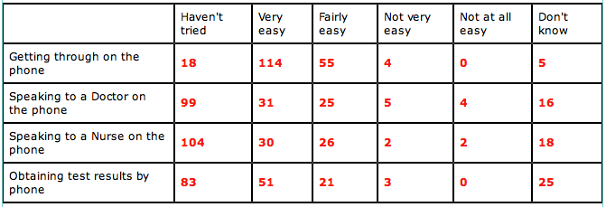
5. In the Reception Area, can other patients overhear what you say to the Receptionist?
119 Yes, but I don't mind
19 Yes and I am not happy about it
26 No, other patients can't overhear
37 Don't know

6. How helpful do you find the receptionists at the surgery
157 Very
41 Fairly
3 Not Very
0 Not At All

7. How long after your appointment time do you normally wait to be seen?
100 I arrive for the Walk-in Service so don't have a specific appointment time
14 I am normally seen on time
17 Less than 5 minutes
69 5 to 15 minutes
18 15-30 minutes
2 More than 30 minutes
2 Can't remember

8. How do you feel about how long you normally have to wait?
117 I don't normally have to wait long
28 I have to wait a bit too long
3 I have to wait far too long
60 I use Walk-In service so understand I may have to wait if there are a lot of patients before me

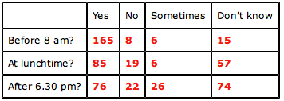
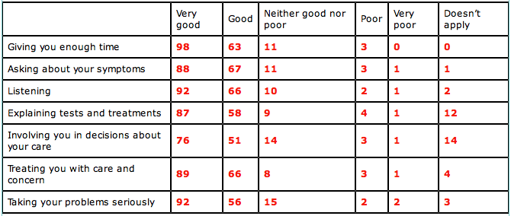
9. How satisfied are you with the opening hours at the surgery
135 Very
45 Fairly
6 Neither satisfied nor dissatisfied
8 Quite dissatisfied
2 Very dissatisfied
1 Don't know opening hours

10. As far as you are aware is the surgery open......

Survey – Clinical Care

1. The last time you saw a Doctor or Nurse Practitioner at the surgery how were they at each of the following?
2. Did you have confidence and trust in the Doctor or Nurse Practitioner you saw?
139 Yes, definitely
36 Yes, to some extent
1 No, not at all
4 Don’t know/can’t say

3. Last time you saw the Practice Nurse at the surgery, how did you find the Practice Nurse at each of the following?

4. Did you have confidence and trust in the Practice Nurse you saw?
126 Yes, definitely
34 Yes, to some extent
1 No, not at all
6 Don’t know/can’t say

The opening hours of the practice premises and the method of obtaining access to service throughout core hours are as below:

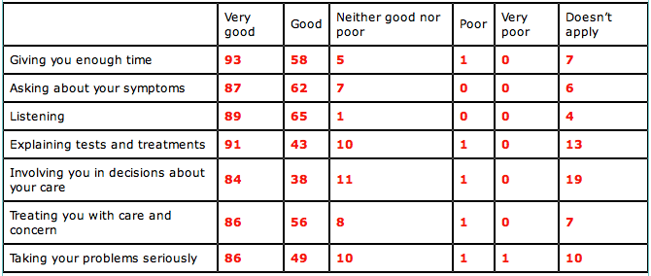
Premises opening times are 7.00 AM to 6.30 PM Monday to Friday except Thursday when practice closes at 1PM

Walk in surgeries with uncapped number of attendances are …..
Monday to Friday 7.30 AM – 10.30 PM when you may request which clinician you would like to see and on Friday afternoon between 2.30 PM to 4.00 PM

Telephone consultation times …..
Any number of patients can telephone before 10.30 am Monday to Friday a clinician will return your call that morning usually before 12.00

Booked appointment times …..
Monday between 2.30 pm to 5.30 pm
Tuesday between 2.30 pm – 5.00 pm
Wednesday between 2.00 pm – 6.30 pm
Thursday 8.30 am to 12.30 am
Friday between 7.30 am to 1.00 pm

Telephone cover by clinician on clinical matters Monday to Friday 7.00 AM to 6.30 PM.

Copy of this report has been sent to Primary Care Contracting Team, PRG, LINk (Local Involvement Networks) and published on the Practice website.

